## **Project “RPG” 1-Page GDD**

*Brief Summary or Hook*

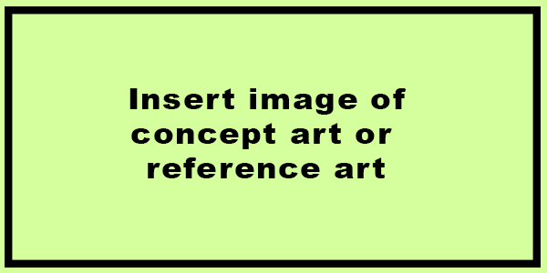

**Genre:** 3D RPG, fixed cam  
**Target Audience:** T & A

**Controls:** Mouse&keyboard/controller

**Thematic Setting:** futuristic

**Tech Stack:** Unity 2017+, Gimp, Blender, Audacity

**Platform(s):** PC(Steam?)

**Game Moment:**

**Game Summary:**

**Core Player Experience:**

**Central Theme:**

**Design Pillar:**

**Anticipated Remarkability:**

**Anticipated Steam Early Access Launch date:**

**Feature Development Priorities:**

**Comparative Products:**